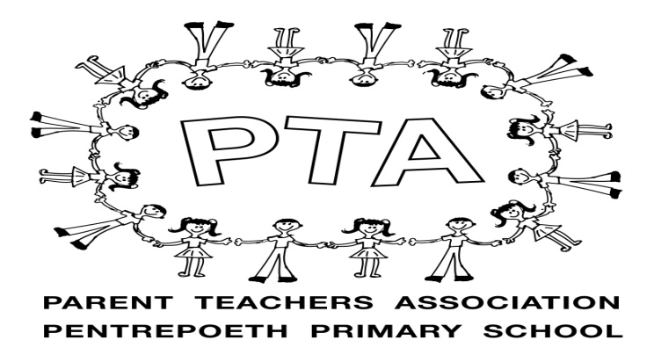
Parent Teacher Association
Pentrepoeth Primary School
Please join us for our first meeting on
Thursday 1st October
It will be done via Microsoft teams so as to comply with social distancing
Please email the school if you would like an invite sent to you via email
pentrepoeth.primary@newport.gov.uk
To help out our amazing office staff can you please put ‘PTA meeting’ as the subject
Microsoft teams can be downloaded as an App or via the link sent on your invite.
AGM starts at 1930
Chair report
Treasurer report
Election of committee (Chairperson/Treasurer/Secretary and Committee Officers)
If you want to join the committee this year please send an email with which role you’d like to be put forward for to pentrepoethpta@gmail.com so we have your interest noted down before the meeting.
Acceptance of the constitution https://www.parentkind.org.uk/uploads/files/1/ConstitutionEW.pdf
Main meeting to follow
Welcome to new members
Request for funding off school
Covid safe fundraising ideas
Any other business
Please join us if you can it would be great to have the support, new ideas and members -the more the merrier!!

